Dominic Garrity

The purpose of this assignment is practicing dealing with runtime erros by means of using throws and exceptions. We implement this method of C++ by using a water tank class. When certain errors are caught, such as trying to add more water than the tank can handle, exceptions will be thrown to allow the program to continue.

Class

WaterTank

domain

Every water tank has a length, width, height, and a water level.

Operations

Have a default tank

Set the tank

Get volume of tank

Get water volume of tank

Add Water to tank

Draw water from tank

Compare two tanks water volume

Compare if first tank is greater than second tank

Compare if second tank is less than second tank

Checks if tank 1 has enough volume left to take ALL water from tank 2, if so it empties

tank 2 into tank 1

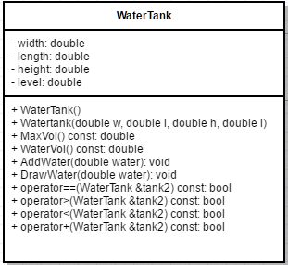

Class

NotEnough

Domain

Operations